**Cereal Killer 01**

***Reverse***

**Challenge:**

How well do you know your DEADFACE hackers? Test your trivia knowledge of our beloved friends at our favorite hactivist collective! We’ll start with bumpyhassan. Even though he grates on TheZeal0t a bit, we find him to be absolutely ADORKABLE!!!

Choose one of the binaries below to test your BH trivia knowlege.

Enter the flag in the format: flag{Ch33ri0z_R_his_FAV}.

Attached - Windows and Linux Binaries

**Approach:**

Upon running the linux binary we see it asks us for a input asking about bumpyhassan’s favorite morning cereal:

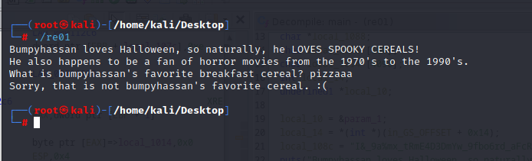

We open it up in ghidra and here’s what we got decompiling the main function:

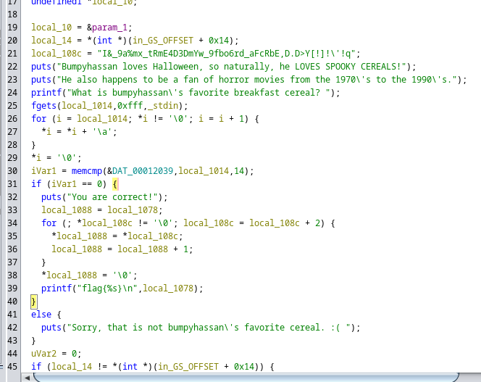

We’re going to focus only on specifically a few lines,

the line which mentioned the value of local_108c:

local_108c = "I&_9a%mx_tRmE4D3DmYw_9fbo6rd_aFcRbE,D.D>Y[!]!\'!q";

and the lines after when the system puts ‘You are correct!’ which tells the system what operations to perform on the string defined by local_108c.

Upon checking the for function carefully, we see all it does is basically compare the alternate characters in the given gibberish string and putting it on a different string then outputting the string.

So to get the solution, we’ll just traverse through the gibberish string through alternate characters and we get this:

I_am_REDDY_for_FREDDY!!!

Since this is what the program outputs after the operation, this would be our flag:

**Flag: flag{I_am_REDDY_for_FREDDY!!!}**

Congrats!!

Happy Hacking!